Link: https://scottlinux.com/2014/11/09/how-to-backup-and-restore-your-android-device-with-adb/

How to Backup and Restore your Android Device with adb
By Scott Miller | 2014/11/09
4 Comments

Backup your Android Device with adb! No root required. This procedure backs up your device to a single file which can also be easily restored.

1. Enable USB Debugging on your Device
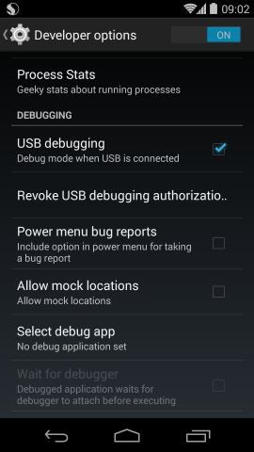

2. Run adb devices to verify device is visible
$ adb devices
Example:
$ adb devices
* daemon not running. starting it now on port 5037 *
* daemon started successfully *
List of devices attached
06649f1ef0ec7bc1 device

3. Backup with adb backup
The command to create a backup is:
$ adb backup -apk -shared -all -f mybackup.ab
As an example, consider tacking on the date to the file name:
$ adb backup -apk -shared -all -f nexus5_444_2014110501.ab
For best security, provide a password on your device for the backup.
The backup can take 5-10 minutes depending on the size of your backup.
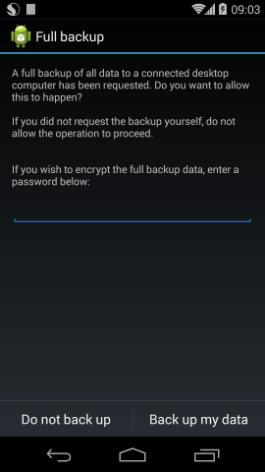

Restoring from backup
Restoring replaces your phone contents with the backup.
To restore, use:
$ adb restore mybackup.ab
Example restoring my backup file:
$ adb restore nexus5_444_2014110501.ab

